The Institute of Construction Management
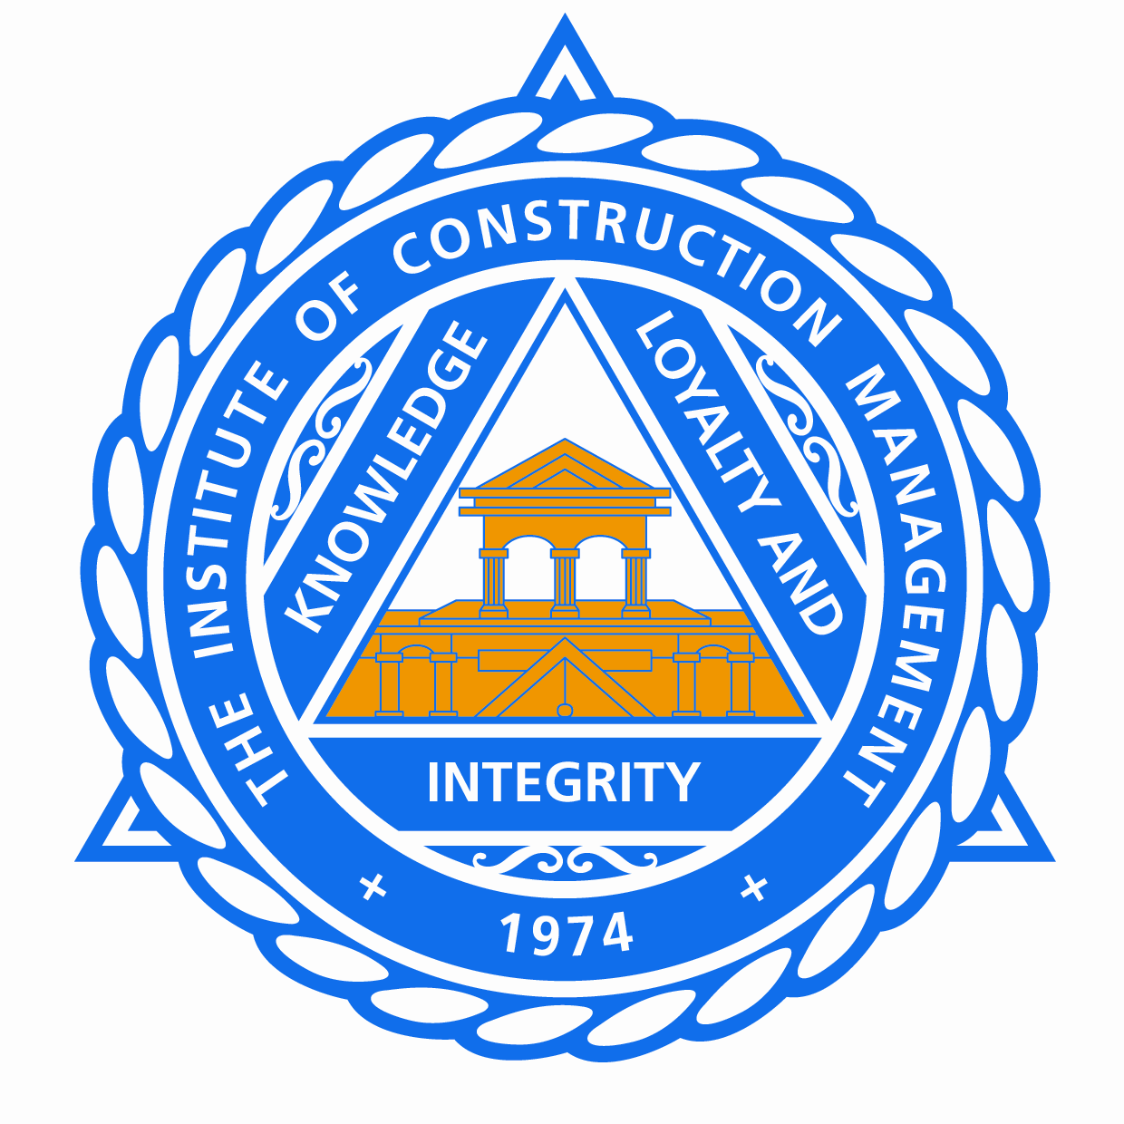
South East Region
Programme and Booking Form
for
Regional CPD Meeting [2 hours CPD]
“Reduction of Musculoskeletal Disorder through Design”

to be held on Thursday May 24th 2018
Venue: St. Francis Social Club, Princess Royal Hospital, Haywards Heath
Programme
The Meeting commences at 6.00 pm for 6.30pm start with coffee and light refreshments.
18.00 Registration and Coffees with light refreshments
18.25 Welcome and Introduction – Roy Blamey - Chairman
18.30 Speaker – Philip Baker

The SPEAKER, Philip, a Past President of the Association for Project Safety and a Certified Fellow, has been involved in a wide range of projects as CDM-C/PD and has advised the full range of duty holders on how they can discharge their duties effectively.

Work related musculoskeletal disorders are the most commonly reported cause of occupational ill health in Great Britain. The prevalence in the construction industry is high, higher than in health and social care. We are all aware of the negative impact that worker ill health is having on our industry and if it carries on unabated the industry’s capacity will continue to diminish and we will not be able to create the housing, infrastructure and amenities that this country needs.

This is a Regional Meeting organised by The Institute of Construction Management South East Region.
Booking Form
Regional CPD Meeting
“Reduction of Musculoskeletal Disorder through Design”
Please use a separate form for each delegate: photocopy this form as necessary.
DATA PROTECTION ACT: The personal data (as defined by the Data Protection Act 1998) (“the Act”) provided on this form by the delegate will only be used by ICM and the organiser for the express purpose of booking attendance at the stated event and will not be further processed for any other purpose whatsoever and shall be kept secure only as a record of attendance to ensure that it fully complies with the Act.
Please tick the box to agree that your personal data may be used for the purpose stated above
If you DO NOT wish to receive information about future events then Please tick the box …
I wish to attend the Regional Meeting at Haywards Heath on Thursday 24th May 2018 – Please reserve a place for me...

Delegate Details :- | ^{Title :- Mr / Ms / Dr /}
 | ^{First Name :-} | ^{Surname :-}
 | ^{Tel :-} | ^{e-mail :-}

Company Details :- | Contact Name (if not delegate) :-
 | ^{Company Name :-}
^{Address :-}

^{Postcode :-}
How to make your booking – This event is free of charge but you do need to complete and return a booking form to ensure your place at this event. Ref
ICM Refreshments will be provided for which a charge of £5 will be collected on the day
Forms should be returned to the Event Organiser either by e-mail at rb@goddardconsulting.co.uk
Or by post to:
Roy Blamey, 3 Crest Close, Badgers Mount, Sevenoaks, Kent, TN14 7AF
Please contact the Event Organiser, Roy Blamey, on 020 7042 9800 or 01959 533452 if you have any queries

Whilst the organisers will make every effort to ensure that the event goes ahead as advertised, it may be necessary to make last minute changes by using substitute speakers, omitting sessions or presenting sessions at different times to those advertised, wherever reasonably practicable every effort will be made to give you advance notice of any changes..
For information on future ICM Conferences, Seminars and CPD Events please contact the ICM National Secretary – Di Charlton on 01273 453394 or by e-mail: cliftonbrown@virginmedia.com
Registered Office: 24 Landport Terrace, Portsmouth, PO1 2RG - Registered in England No. 1386526

